**M S RAMAIAH INSTITUTE OF TECHNOLOGY**

**(Autonomous Institute Affiliated to VTU)**

**Department of Information Science and Engineering**



Jan 2020 - May 2020

Topic:

**“BREAK-OUT GAME”**

*Submitted in fulfillment of the CIE for the subject*

**Java & J2EE**

**IS63**

**Signature of Faculty Project Team-**  Mr.Prashanth Kambli Pranav.R.Hegde

**Table of Contents**

|  |  |  |
| --- | --- | --- |
| **S.No** | **Topic** | **Page No.** |
| 1 | Abstract | 2 |
| 2 | Introduction | 3 |
| 3 | Workflow Diagram | 4 |
| 4 | Conclusion | 7 |
| 5 | References | 8 |

# **Abstract**

# The project that is going to be implemented will consist of a game in which the player smashes a wall of bricks by deflecting the bouncing ball with a paddle. The paddle will only move in a horizontal way and will be controlled by the player with the left and right arrows of the keyboard.

# The player will win this game after destroying all the bricks in the level. Similarly, the player will lose if he fails to catch the ball with the paddle 1 times.

# **Introduction**

In our game, we have one paddle, one ball and 30 bricks. I have created an image for a ball, paddle and a brick in Inkscape. We use a timer to create a game cycle. We do not work with angles, we simply change directions. Top, bottom, left and right, It was developed in java,

When the paddle is miss the game is over, its popup an massage box, and restart with the again 30 bricks.

And if the person is finish the all bricks according to the rules he finish the game, and we used a timer for paddle ..

The game consists of seven files:

 Commons.java, Sprite.java, Ball.java, Paddle.java, Brick.java, Board.java, and Breakout.java.

# **Workflow Diagram**

RENDERINNG

# 

BALL

BOARD

BREAKOUT

BRICK

COMMMANS

# IF

BRICK==0

PADDLE

# **TRUE**

SPRITE

TASK COMPLETED

# 

ELSE

ELSE

IF

WAIT FOR PADDLE

TRUE

PADDLE==MISS

CONTINUE

# **ScreenShot:**

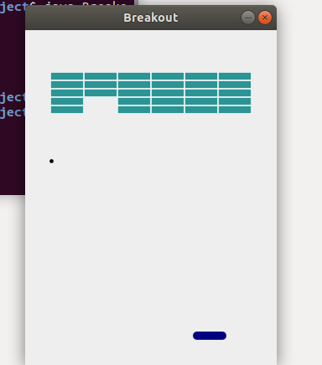

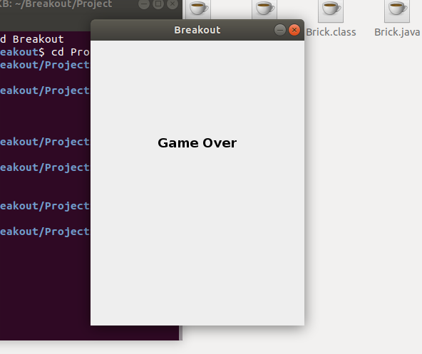

When the paddle is miss game over massage will be popup.

# **Conclusion**

# This final project was loads of fun and was a good use of what we had worked on throughout the semester.  It was so much fun making all the little upgrades to our game.  We would think of new features to add and new ideas at the most random times.

# **References**

Java The Complete Reference, Seventh Edition

Youtube link :[Java-Breakout-Game](https://github.com/janbodnar/Java-Breakout-Game)